Contract for the sale and purchase of a puppy

- Puppy details

Kennel Club registered name of dog
Kennel Club registration number
Breed
Date of birth
Sex
Colour
Microchip number

This is to confirm that the sale of the dog described above (the puppy) is between:

- Details of parties

Seller’s name
Seller’s address
Seller’s telephone number

and

Buyer’s name

Buyer’s address
Buyer’s telephone number
Definitions
- ‘Puppy information pack’ refers to the puppy information pack that sets out the dog health information and future health and welfare needs and forms part of this agreement
- ‘Dog health information’ means the information about the puppy, its parent and grandparents, and these animals’ health and temperament
- ‘Good health’ means a condition of health free of parasites and hereditary disorders and of reasonably sound physical condition and temperament
- ‘Future health and welfare needs’ means the measure that should be taken to ensure that the puppy is and remains in good health and is properly housed, fed, watered, trained, socialised and exercised and that it receives appropriate veterinary attention
- ‘Seller’ means the seller of the puppy defined above, whether or not the breeder of the puppy

- The seller warrants

  - That if the buyer has previously selected the puppy from a litter or in any other circumstances, that the puppy sold under this contract is the puppy that the buyer has previously selected

  - That the genetic health checks and health screening set out in the puppy information pack have been carried out on the puppy’s parents and explanation of what this means for the puppy is provided in the puppy information pack.

  - That the puppy is not the result of a mating of two dogs related within two generations.

  - That the puppy is in good health, other than as is outlined below under clause 6 Veterinary Check and clause 7 Health Schedule and as the seller specifically informs the buyer before the date of sale.

  - That he/she has supplied the puppy information pack prior to the buyer viewing the puppy or a reasonable period in advance of the buyer’s decision to buy the puppy, and has communicated to the buyer within the puppy information pack:

- the possible consequences of buying the puppy given the dog health information, the genetic health checks and health screening carried out under clause 3.2 and the particular considerations that are likely to affect the puppy given its breed

- the meaning of any Kennel Club endorsement

- the measures that should be taken, whether by neutering, contraception or otherwise, to guard against unwanted pregnancy and

- the future health and welfare needs of the puppy

  - That the information contained in the puppy information pack, supplied to the buyer under clause 3.5 above is accurate and materially complete (to the best of the seller’s knowledge and belief where the information is supplied by a third party) and all diagnostic tests for the puppy have been undertaken as recorded in the dog health information and that reasonable care and skill is and/or will be used when explaining to the buyer the future health and welfare needs of the puppy and any advice or recommendations provided under clause 4.5 below.

  - That he/she is a certified member of The Kennel Club Assured Breeders scheme, he/she has adhered to the standard and all requirements and recommendations under the scheme as set out in The Kennel Club Assured Breeders Standard and/or as provided to the buyer.

  - That he/she, having made reasonable enquiries of the buyer, in good faith believes that the buyer is able to meet the puppy’s future health and welfare needs.

  - That the puppy is more than 8 weeks old at the date of sale.

  - That the puppy has received adequate care and that the seller has provided it with the opportunity to socialise with dogs, humans and other animals it is likely to come into contact with and it has experienced and become accustomed to the sounds and experiences of typical family life.

  - That, any pedigree indicated for the puppy is correct. Where appropriate, the seller will provide the buyer with all relevant registration papers and pedigree certificate within one month of the date of sale, or as soon as it is available.

- The buyer warrants

  - That he/she has read and understands the information provided to him/her under clauses 3.2-3.5 above and contained in the Puppy Information Pack.

  - That he/she in good faith believes that he/she will be able, and intends, to meet the puppy’s future health and welfare needs.

  - That neither he/she nor any member of his/her household has been cautioned for or convicted of any breach of animal welfare law such as neglect, cruelty or abandonment.

  - That he/she shall not breach the terms of any Kennel Club endorsement.

  - That in the event that he/she is no longer able or willing to provide a home for the puppy or otherwise to meet the puppy’s future health and welfare needs he/she will contact the seller and have regard to any advice and recommendations that the seller provides, including return of the puppy at the option of the seller.

  - That he/she is purchasing the puppy for himself/herself and not as an agent for a third party.

- Both buyer and seller agree and understand:

  - That the puppy is a living creature with interests independent of both buyer and seller.

  - That the buyer may suffer distress and inconvenience as a result of the puppy suffering pain or discomfort and one purpose of the seller's warranties is to reduce or avoid such distress and inconvenience.

  - The buyer shall be entitled to recover from the seller his reasonable veterinary fees and costs to treat a serious disorder suffered by the puppy that relates to a breach of any of the seller’s warranties.

  - Nothing in this contract affects the buyer’s statutory rights including any warranty of satisfactory quality of the puppy implied by sale of goods legislation or other law.

  - The buyer agrees to take the puppy to their vet, soon after purchase, for a general health check and advice on inoculations and worming.

- Veterinary Check

  - The seller has taken every care with the breeding, rearing and welfare of the puppy. The seller makes no warranty however as to the long term health or disposition of the puppy

  - Every effort has been made to avoid any possible inherited conditions. Conditions known/thought to be inherited in the breed are:

  - Relevant, existing screening schemes have been used and copies of relevant screening results have been provided.

  - The puppy has been checked by a veterinary surgeon prior to sale. Although no warranty can be given on the future health of the puppy, the outcome of that check has been passed on to the buyer together with the details of the veterinary surgeon who carried it out.

Date puppy checked
Details of veterinary surgeon

  - The seller hereby confirms that details of the outcome of this veterinary check are provided below in section 7. Health Schedule

- Health Schedule

The seller hereby confirms that any faults or defects in the puppy, as identified by themselves or during veterinary examination, have been outlined in section below.

- Endorsements
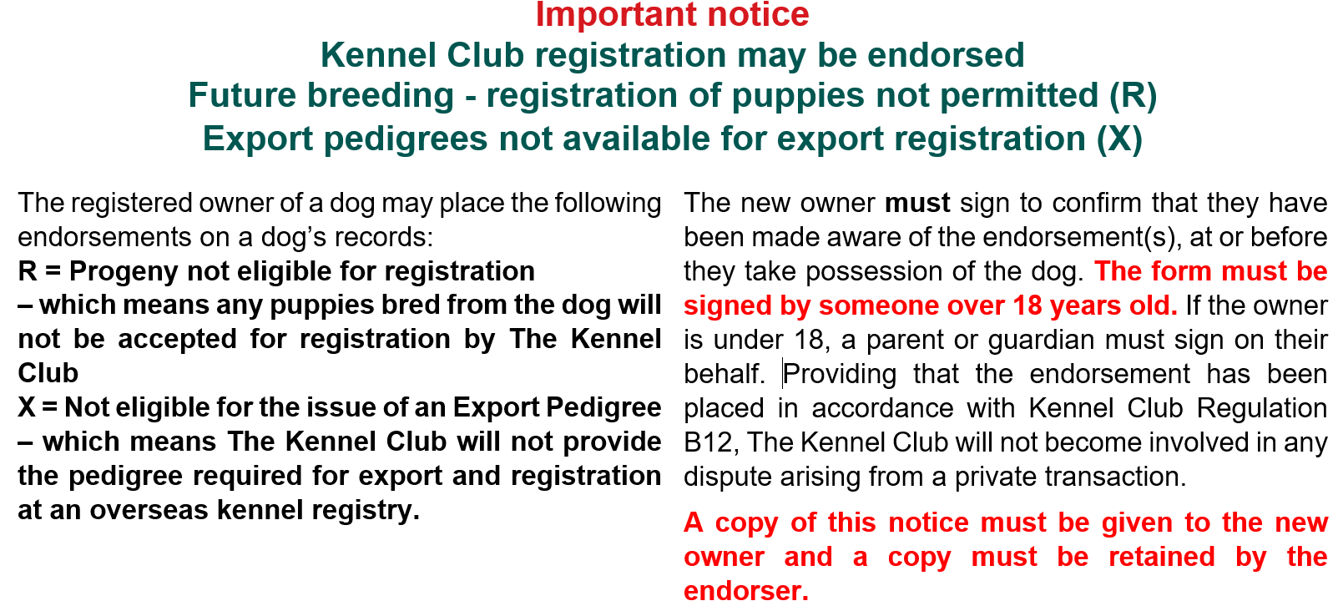
  - The seller hereby confirms that the puppy is subject to the following endorsements:
R: Progeny not eligible for registration:
☐ Placed
X: Not eligible for issue of an Export Pedigree:
☐ Placed
  - The buyer hereby confirms that they are aware of the endorsement(s) detailed above.

- Date, declarations and signatures

Date of sale and purchase

Purchase price received by seller

Buyer: By signing this contract I agree and understand that I am entering into a legal and binding contract.

Signed

Date

Seller: By signing this contract I agree and understand that I am entering into a legal and binding contract.

Signed

Date

Two copies to be printed – One copy to be retained by seller, one copy to be retained by buyer

